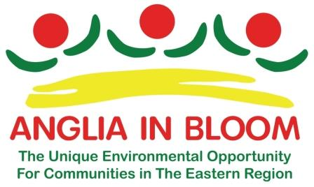
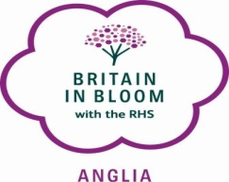
ANGLIA IN BLOOM ANNUAL AWARDS
APEX THEATRE, BURY ST EDMUNDS
12TH SEPTEMBER 2018

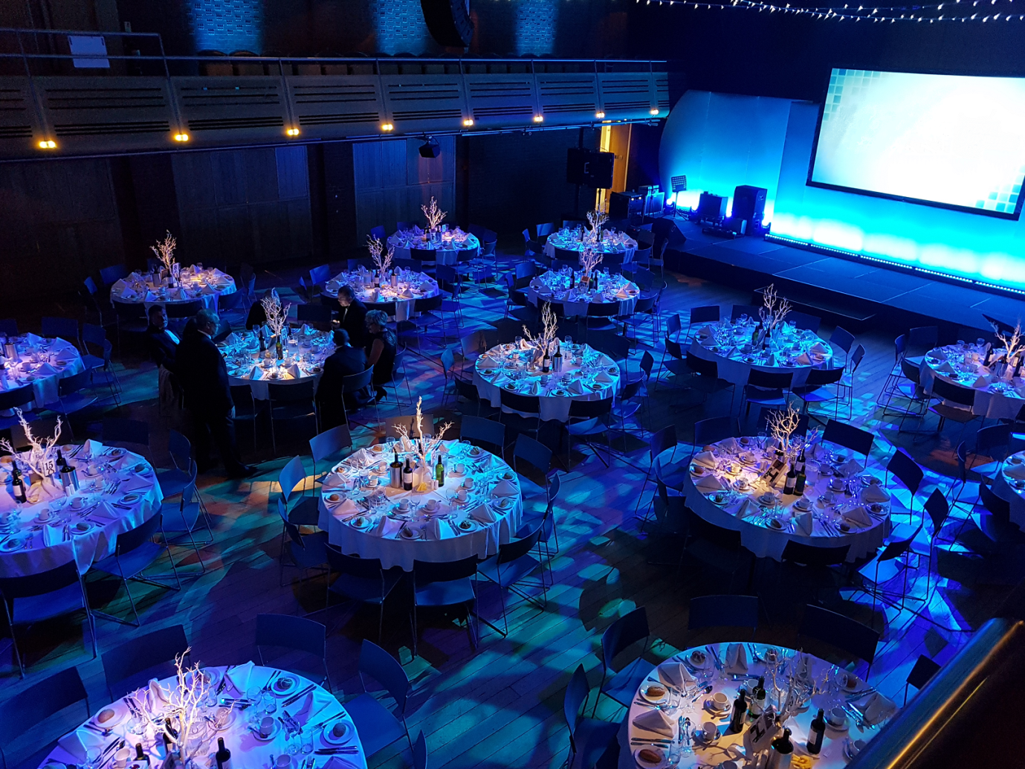

Anglia in Bloom invites all participants and guests to our 2018 Anglia in Bloom Campaign Awards Ceremony to be held at the Apex Theatre, 1 Charter Square, Bury St Edmunds, IP33 3FD.
An exciting menu for a two course sit down meal, (see choices, below) tea/ coffee upon arrival. Cost £30.00 per head, unfortunately limited numbers so book early to avoid disappointment.
The event will commence at 10.30am lunch will be served from 1pm.
You are advised to use the long term car park situated at 3 Park Way, IP33 3BA.
See map below.

Two Course Menu
Please select one main, one dessert.
Main Course:
A Chicken wrapped in Parma ham and sage, Hasselback potatoes and roasted root vegetables (G.F)
B Slow braised blade of beef presented on grain mustard mash, baby silver onions, mushrooms, green beans and rich red wine sauce (G.F)
C Sweet potato, butternut squash and chickpea Tagine, pomegranate, pistachio and pine nut couscous (Vegan, veggie, GF DF)
Desserts:
A Warm nutty Chocolate brownie, local double vanilla ice cream and hot chocolate sauce (veggie)
B Meringue filled with mascarpone cream, fresh strawberries and passion fruit sauce (G.F, veggie)
C Steamed toffee, banana and walnut sponge pudding, toffee sauce, lightly whipped cream (veggie)

Please select your choice:
Main Course
A
B
C
Dessert
A
B
C

Name...................................................................................................
Address..................................................................................................
...................................................................................................
Contact Telephone.................................................................................
Email......................................................................................................
All contact details are for the sole use of Anglia in Bloom and will not be shared with other agencies.
Payments can be made by BACS to Sort code 20 62 53 account number 90704385
or by cheque made payable to Anglia in Bloom and sent with your choices from the menu to:-
Mrs M Spencer, 102 London Road, Rayleigh, Essex SS6 9JA.
Please keep a copy for your own use.

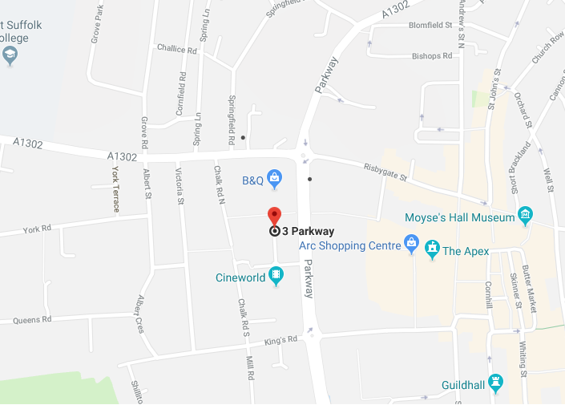

Parkway multi storey car park
Address: Parkway multi storey, IP33 3BA
Charges from:
Long stay - Monday to Friday 8am to 6pm
Cost:
Monday to Friday - Long stay:  Up to 2 hours £1.80  Up to 3 hours £2.00  All day £2.70 | Saturday - Short stay only:  Up to 2 hours £2.00  Up to 3 hours £2.50  Up to 4 hours £3.00 | Sunday - Short stay only:  Up to 4 hours £1.50

Blue Badge:
Monday to Friday - Long stay:  Up to 4 hours £1.80  All day £2.00 | Saturday - Short stay only  Up to 4 hours £2.00 | Sunday - Short stay only:  Up to 4 hours £1.50

